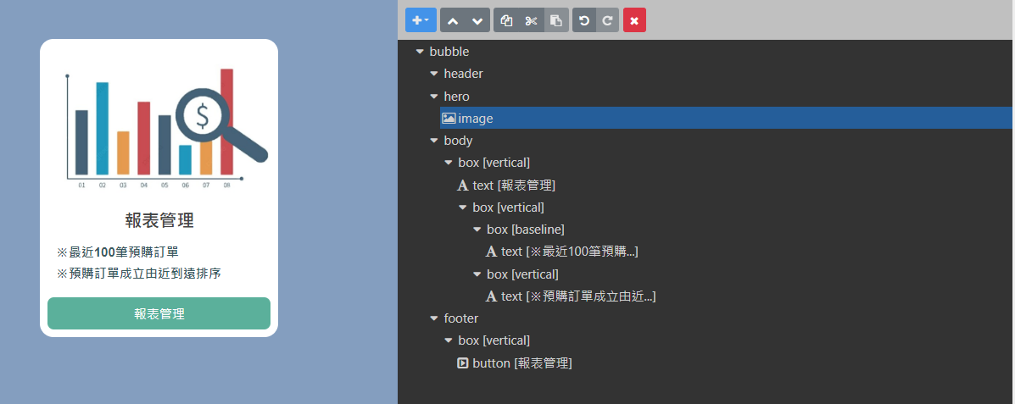

{

"type": "bubble",

"hero": {

"type": "image",

"aspectRatio": "20:13",

"url": "https://i.imgur.com/V8091Bp.jpg",

"align": "center",

"margin": "none",

"animated": true,

"aspectMode": "fit",

"size": "full",

"offsetTop": "md"

},

"body": {

"type": "box",

"layout": "vertical",

"contents": [

{

"type": "text",

"text": "報表管理",

"weight": "bold",

"size": "xl",

"align": "center"

},

{

"type": "box",

"layout": "vertical",

"margin": "lg",

"spacing": "sm",

"contents": [

{

"type": "box",

"layout": "baseline",

"spacing": "sm",

"contents": [

{

"type": "text",

"text": "※最近100筆預購訂單",

"color": "#3b5a5f",

"size": "md",

"flex": 5,

"weight": "bold"

}

]

},

{

"type": "box",

"layout": "vertical",

"contents": [

{

"type": "text",

"text": "※預購訂單成立由近到遠排序",

"color": "#3b5a5f",

"size": "md",

"flex": 5,

"weight": "bold"

}

]

}

]

}

]

},

"footer": {

"type": "box",

"layout": "vertical",

"spacing": "md",

"contents": [

{

"type": "button",

"style": "primary",

"action": {

"type": "message",

"text": "【報表管理】報表管理",

"label": "報表管理"

},

"height": "sm",

"color": "#5bb09b",

"offsetTop": "none"

}

],

"flex": 0,

"margin": "sm"

}

}